Title
Faegan White – 20056628

Introduction

This paper will look at the use of genetic algorithms (GAs) in the role of data mining, specifically with 3 aims: Firstly, a genetic algorithm for the role of data mining should be implemented and explored how parameters affect the testing and training ability of this algorithm. Secondly, the use of a GA in data mining will be compared with another meta-heuristic algorithm, the Social Spider Algorithm (SSA) to see how both techniques differ in approach and result. Finally, this paper will extend the the capabilities of the data mining GA to develop an automated solution to devising the minimum number of rules required to represent an optimal heuristic for categorising a data set, and use this optimised rule set to generate manual inferences about the data set being categorised.

Background Research

Meta-heuristic algorithms is a successful, developing field of artificial intelligence which aims to use higher-level procedures in order to construct or select a heuristic for solving a given problem (Hussain et al., 2019). This category can be split into single solution or population based algorithms, the latter of which concurrently compute multiple solutions giving them an exploratory advantage provided by communication and interaction amongst solutions (Turgut and Turgut, 2020). Many population based meta-heuristic algorithms can be considered NIOAs or Nature-inspired optimisation algorithms, which are developed using phenomena from nature as inspiration (Wang et al., 2021) but a key need of all these algorithms is to determine the correct balance between exploration and exploitation for effective search performance (Črepinšek et al., 2013). A focus on exploration will find many new solutions but have trouble converging on a solution while exploitation is likely to become stuck in a local optima (citation needed). Two examples of NIOAs are Genetic Algorithms and Social Spider Optimisation, the first being a procedure based algorithm taking inspiration from the metaphor of biological evolution (Wang et Al., 2018), while the latter is an equation based swarm intelligence, using vectors like Particle Swarm Optimisation (Yang, 2020) while taking inspiration from social spider colonies. Comparison of meta-heuristic algorithms is important for the development of hybridised solutions and determining the most effective approaches for different problem domains (Wang et al., 2021). Because of this, we are looking to compare genetic algorithms with social spider optimisation from the key issues in multi-population models as defined by Ma et al. (2019).

One similarity between genetic algorithms and social spider optimisation is problem representation, both of which use a list of values to define the properties of the heuristic they represent. However, in a genetic algorithm this sequence or solution is labelled a gene (Lin et al., 2015) while in SSO each spider (solution) represents a position in an N-dimensional web, where N defines the dimensions of the problem space (Cuevas and Cienfuegos, 2014). This leads to a key problem in multi-solution algorithms, the communication between solutions or subpopulations (Ma et al., 2019). Here, genetic algorithms use the processes of crossover to pass information between solutions, generating new genes from parents across the problem space and evaluating their fitness so that beneficial features are generated and remain while others are lost from the gene pool (Wang, et al., 2018). In comparison, SSO uses the concept of web vibrations to transmit information between spiders, where the strength of the vibration is dependant of the size of the spider (solution fitness) and distance from the other solution in the web (solution similarity) (Cuevas et al., 2013). Muti-population models also require a search method to find new solutions (Ma et al., 2019). Although crossover plays a large role in this, mutation is another mechanism present in genetic algorithms which provides a searching force by randomly modifying a number of the solution’s genes (Alam, 2020). In SSOs however, spiders traverse the web stochastically according to their state and incoming vibrations in order to search the problem space (Cuevas et al., 2013). Building on this, SSO separates the population into ‘male’ and ‘female’ spiders, each sex with its own evolutionary rules, and the ability to reproduce together to create a new population of solutions. This individual categorisation reduces the risk of premature conversion and further tunes the balance between exploration and exploitation (Luque-Chang et al., 2018).

Ultimately, genetic algorithms are a general purpose search method with an effective balance between exploration and exploitation (Michalewicz, 1996) as long as the parameters are tuned correctly. They are particularly effective for large scale, non-convex optimisation problems (James and Li, 2015) such as data mining. SSOs however are only efficient for low-scale optimisation problems and have poor performance with continuous data sets with more than 10 dimensions in the web (Baş and Ülker, 2020). Because of this, a closely related algorithm called the Social Spider Algorithm is more commonly used for data mining applications (Emine and Ülker, 2020) and will be investigated later in this paper in comparison to genetic algorithms. The key differences are the use of consistent evolutionary rules (aka. no concept of sex) and the introduction of ‘spider blasting’

Experimentation
Explanation of a Data Mining Algorithm

Data mining is the process of finding anomalies, patterns and correlations within large data sets to predict outcomes (citation needed). In this experiment, the data set consisted of a list of entries, each with a set of properties (represented as value between 1 and 0) and a binary class which it belongs to. To learn which properties define each class, a genetic algorithm was created as described in the background research section using the Python programming language. The code for this can be found at appendix A.

The GA’s genome represents a set of rules, where value pairs represent bounds for which a property must fall between. Each rule constitutes as many pairs as the values of the data set, plus an extra value to represent the binary outcome. Thus, the rule size is 2n+1, where n is the number of data properties. As a genome can consist of any number of rules, the genome length is always a multiple of 2n+1. Example rule from the genome:

0.2569752244532422, 0.7677804675200207, 0, 1, 0, 1, 0, 0.6888602357571432, 0, 0.15995737319298753, 0.26000303037706174, 0.9649481569648961, 0.07749397011045515, 0, 1, 0.44498009030002783, 0.7364319508474593

The key operations of the GA consisted of single point crossover (citation needed) around a randomly defined point in the first parent genome and mutation, controlled with parameters which balanced exploration, exploitation and algorithmic complexity. These parameters are…
- max_val – the maximum value in a genome
- min_val – the minimum possible value in a genome
- population_size – the number of solutions in any given generation
- generations – the number of generations
- rule_number – how many rules make up the genome
- tournament_number – how many individuals are used in tournament selection
- mutation_chance – the chance of any value in the genome mutating for every individual in each generation of the algorithm
- mutation_amount – the maximum amount the value in the genome can change by when mutating
- repeat_times – number of times to repeat the entire algorithm in order to create a more reliable, averaged result

The fitness function was the number of items from a list for which the heuristic could successfully predict the class. This was done by comparing the values of each item against each rule in turn, incrementing the fitness and moving to the next item if successfully matched.

To determine the highest-fitness parameters, a sweep was used to find the fitness for every combination (citation needed). This was performed for each data set, comparing mutation chance, maximum mutation amount and rule number, the results of which were later used to guide the operation of the algorithm. These results can be found at appendix A, B and C. From one sweep, a surface representing how mutation chance and mutation amount affect the algorithm’s fitness was generated (11 rule genome on data set 1). This suggested a mutation rate of 0.12 and a mutation amount of 0.8 were optimal for 11 rules, with fitness decreasing with a smaller maximum mutation amount or higher mutation chance.
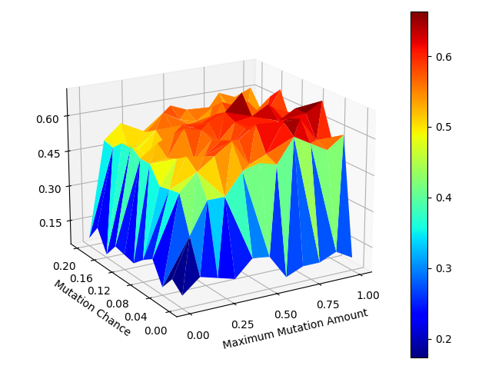

With this sweep information, the algorithm was trained on the 3 data sets. The results of which can be seen in Fig. A, B and C.

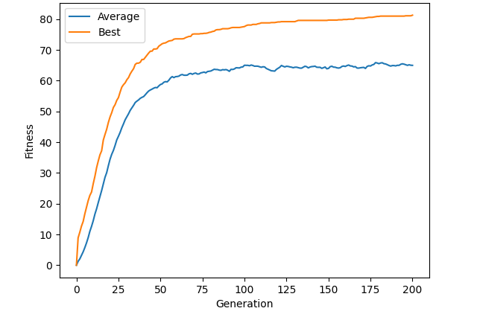

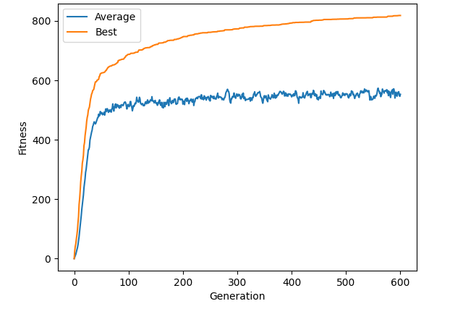

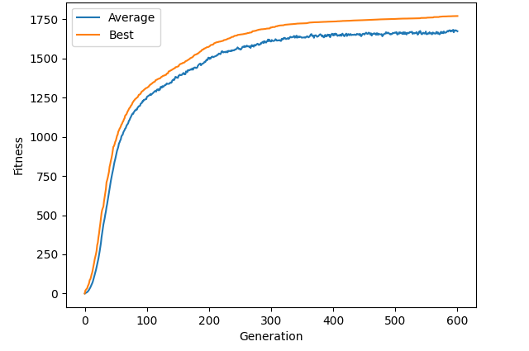
Outside of the sweep, it was determined that increasing the population number found optimal solutions in fewer generations, but with more compute. This is because more concurrent solutions increased genetic diversity for a wider search while reducing the risk of becoming stuck in a local optimum (citation needed). Increasing generation number allowed increased convergence on a higher fitness, with the cost of time. This was especially relevant with data set 2 and 3, which often required 500+ generations to achieve fitness over 80% during training. More rules meant more compute power and time as a larger genome needed to be processes, but allowed for more precise representation of the data. Fewer rules meant faster performance, but too few may was unable to fully capture the complexity of the data (citation needed), leading to reduced maximum fitness. See Fig A.

K-fold validation

To understand true classification accuracy, it is vital to test the solution using unseen data (citation needed). An approach to this is the division of the data into 2 sets, one for training and one for testing (citation needed). However, determine the best ratio is challenging and there lies a risk of loosing important training information present in the testing set (citation needed). K-fold validation overcomes both of these issues by splitting the data into k sets, and then testing 1 set after training with the remaining k-1 sets, repeating the process k times before giving the average testing accuracy of all the sets as the solution’s fitness. This ensures that the algorithm is trained and tested on every data piece, giving a more robust and consistent measure of the algorithm’s accuracy.

As expected, the testing accuracy was reduced compared to training as shown in Table A. However, it can be noted that the larger the data set, the smaller the decrease in accuracy. This is likely because fewer data during training leads to an increased chance of overfitting (citation needed). This affect is magnified during k-fold validation, which further reduces the training data size which has a disproportionate effect on smaller data samples. The average K-fold validation fitnesses for the 3 data sets can be seen compared in Fig A.

 | Data1 |  | Data2 |  | Data3
 | Training | Testing | Training | Testing | Training | Testing
1 | 0.82 | 0.57 | 0.8 | 0.76 | 0.87 | 0.84
2 | 0.82 | 0.58 | 0.8 | 0.78 | 0.87 | 0.84
3 | 0.81 | 0.6 | 0.78 | 0.73 | 0.89 | 0.85
4 | 0.84 | 0.62 | 0.81 | 0.77 | 0.86 | 0.85
5 | 0.82 | 0.58 | 0.82 | 0.8 | 0.89 | 0.85
6 | 0.81 | 0.54 | 0.82 | 0.8 | 0.87 | 0.85
7 | 0.83 | 0.72 | 0.82 | 0.78 | 0.89 | 0.86
8 | 0.83 | 0.61 | 0.8 | 0.77 | 0.87 | 0.84
9 | 0.8 | 0.55 | 0.82 | 0.78 | 0.87 | 0.83
10 | 0.82 | 0.53 | 0.82 | 0.8 | 0.87 | 0.86
Average | 0.82 | 0.59 | 0.81 | 0.78 | 0.88 | 0.85

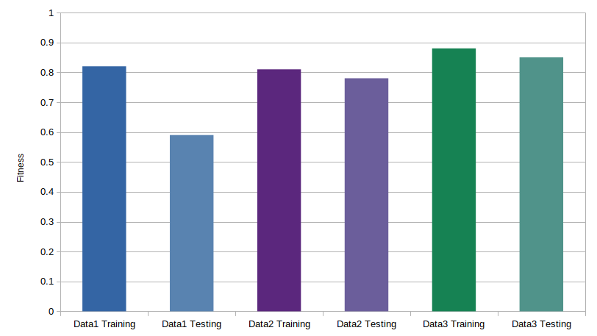

Comparison with Social Spider Algorithm

To compare with the GA, the Social Spider Algorithm was created by obtaining source code from site X, and transferring into it the fitness function from the GA. The SSA represents the problem as an N dimensional web, where the position in each 2 dimensions make up 2 boundary values and 6 boundary value pairs construct a rule, with a 13th dimension being used to represent the output of the rule when rounded. Hence, a 35 dimensional web encodes 5 rules for classification, enabling each spider to become a heuristic for data mining.

The inputs to the algorithms were
- dimension – number of web dimensions, equivalent to the length of genome
- spider_number – number of solutions, equivalent to the population_size
- max_iteration – number of iterations, equivalent to generation_number
- r, c, a

Mapping the performance of a small number of spiders using data set 1 shows that the algorithm tended to get stuck at a fitness of 52: a local minimum representing the highest fitness possible with a single rule, see Fig A. It also shows the large epoch number to achieve fitness comparable to the GA. This suggests the ability of the SSA to either explore the search space or exploit the current position isn’t as effective as the GA for this problem domain.
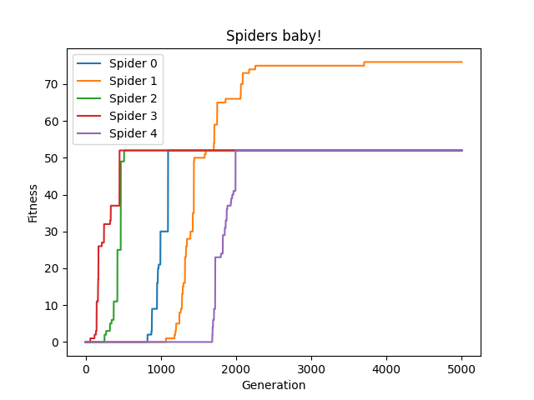
A low average compared to best fitness suggests the spiders are unable to converge on an optimal solution, and hence have a proclivity for exploration over exploitation. It is possible that this problem could be averted by incorporating spider sex based evolutionary operators as in SSO to better fine tune this balance (citation needed).
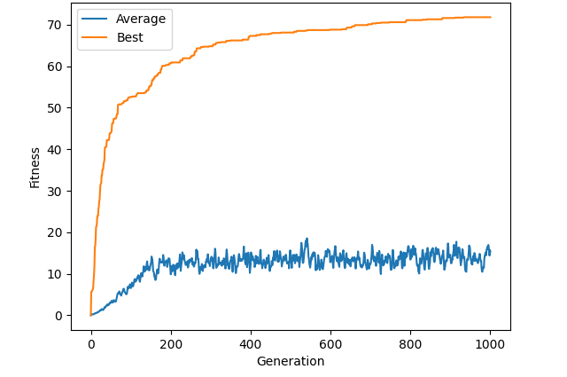
Fig A shows that the fitness increase in the SSA is slower, and it’s unable to reach the same level of accuracy of the GA. Both algorithms use 5 rules with a population of 100.

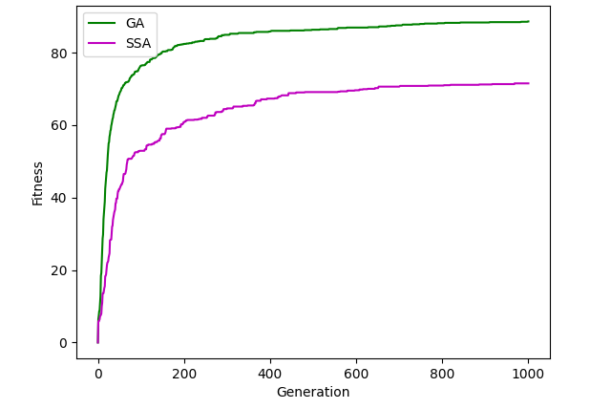
Variable Genome

Allowing the genetic algorithm to evolve its own rule number while calculating solutions is a method to use compute power more efficiently while generating solutions with the greatest balance of accuracy and complexity, all without the need for parameter sweeps (citation needed).

To implement this, single point crossover required adjustment to handle variable length genomes so that the length of the child’s genome always lies between the parents. This was achieved by picking a random point in the smaller genomes length to use as the crossover point, and generating 2 solutions using alternating sections from either parent, before randomly picking one of the results to avoid a bias towards larger or smaller genomes.

To avoid tending towards increasing genome lengths (as there was no cost on rule number), the gene size was introduced as a negative factor of tournament selection using the weighting of v = fitness**2/gene size. This required tweaking to obtain the right balance, so later versions would always prioritise the fitness in tournament selection, unless it was equal at which point the solution with the lowest gene size was selected. Ultimately this had too small of an effect on the rate of rule number change, so a blend of both concepts was used, prioritising fitness until within a defined range, at which point the smallest gene would be selected. This allowed the control of the balance between gene size and fitness with a single parameter: rule_size_factor which defined this range.

The rule_mutation_chance parameter was also added to define the chance that a new random rule would be added onto the end of the individuals genome, or an old rule would be subtracted from the end. This ensured new rule numbers outside the bounds of the parents was being tested, increasing the search capability of the algorithm.

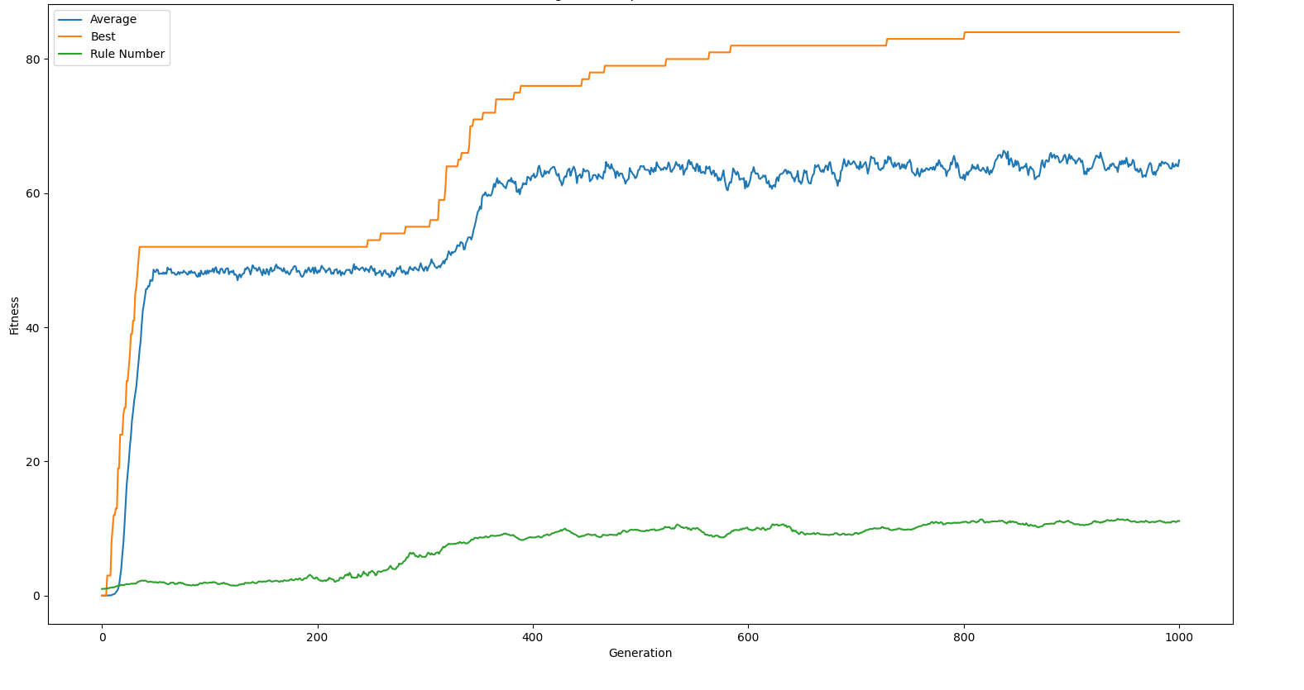
Fig A shows a demonstration of the variable genome GA, starting with 1 rule and learning to increase rule number to improve accuracy beyond 52 (the limit for a single rule).
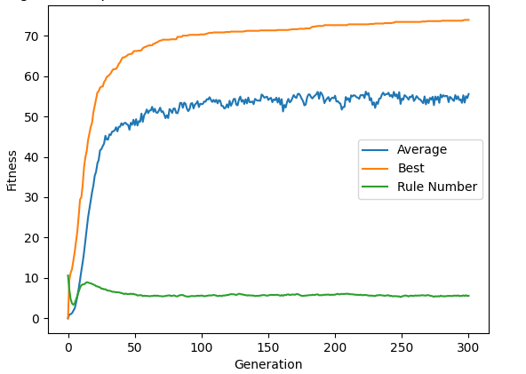

Table A and Fig A shows variable genome training on data set 1, where the average number of rules produced is 6.1 with an average fitness of 0.74. It’s clear that higher fitness can be achieved by the algorithm when defining its own rule number, however it is prone to sticking at the local minimum of 0.52 with a single rule. This is the same local minima that appeared to affect the performance of the SSA.

 | Training | Rule Number
1 | 0.78 | 12
2 | 0.89 | 5
3 | 0.52 | 1
4 | 0.82 | 10
5 | 0.68 | 9
6 | 0.52 | 1
7 | 0.83 | 7
8 | 0.72 | 7
9 | 0.76 | 3
10 | 0.87 | 6
Average | 0.74 | 6.1

To demonstrate that the variable genome was successfully converging on a consistent solution, it was important to test it with a variety of initial rule numbers. Fig A shows a maximum rule number of 40, where the algorithm converges to the same rule number as Fig A.
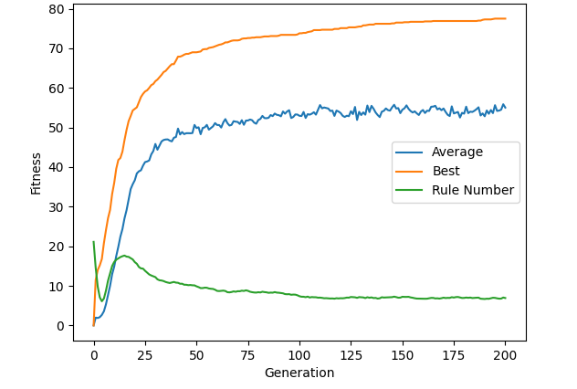
Nested Cross Validation Training

To improve these results, the concept of nested k-cross validation for hyperparameter selection of deep neural networks was experimented with. This method splits every training epoch into a further number of folds, testing each fold using a different value for the hyperparameter before comparing these accuracies and determining the highest to be used as the hyperparameter for the next iteration (citation needed).

This was implemented in the GA by splitting each generation into cross_training_split_number of folds, each fold taking the previous generation’s population and modifying each individual to have a increasing proportion of the maximum rule number of rules. The fold with the highest accuracy, or equal accuracy but a smaller rule number was then selected as the population for the next generation. If a generation was unable to produce an individual with higher accuracy or a smaller rule number, the algorithm will train the new generation with 2 more rules than the previous best generation to stop the solution sticking on a low rule number due to losses of genetic information every generation. To further retain genetic information and hence accuracy after the genome was shrunk, the concept of genome compression was developed, inspired by data compression – the reduction in the number of bits to retain the same information (citation needed).

This scores every individual's rule by the number of data pieces it classified when the fitness was calculated. When a genome was then reduced in size, rules with 0 score (hence provided no fitness) were removed preferentially. This allows genomes to be compressed down much smaller with a reduced affect on the accuracy of the solution, creating an accuracy comparable to the standard training algorithm but with a greatly reduced rule number. Fig A shows this at work on data set 1, developing +80% accuracy with only 4 rules.
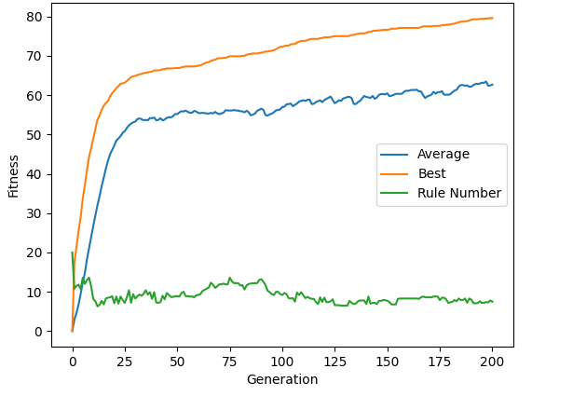
The rule compression system means the the solutions produced are reduced in complexity, improving readability and hence provides a better tool for manual analysis of the results. However, Nested Cross Validation (NKV) requires much more compute power as every generation needs to calculate a magnitude of folds. These results suggest that the variable genome GA is better for tasks where performance is more critical, but NKV may be more powerful when lower complexity, higher accuracy heuristics are preferred. Table A shows a comparison between the 2 techniques, suggesting nested cross validation is both less consistent and has a higher average rule number, however this is due to the presence of outlier results in the data set, items 1 and 4 according to a 90% confidence obtained via the formula for confidence interval:
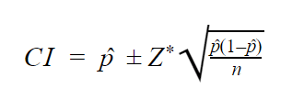

 | Variable Genome |  | Nested Cross Validation
 | Training | Rule Number | Training | Rule Number
0 | 0.78 | 12 | 0.84 | 4
1 | 0.89 | 5 | 0.76 | 21
2 | 0.52 | 1 | 0.82 | 4
3 | 0.82 | 10 | 0.75 | 7
4 | 0.68 | 9 | 0.75 | 21
5 | 0.52 | 1 | 0.84 | 4
6 | 0.83 | 7 | 0.86 | 4
7 | 0.72 | 7 | 0.82 | 4
8 | 0.76 | 3 | 0.73 | 2
9 | 0.87 | 6 | 0.79 | 4
Average | 0.74 | 6.1 | 0.8 | 7.5
Std. Dev. | 0.13 | 3.7 | 0.05 | 7.21

A simple filtering technique could be used to re-calculate results when the resulting rule-number extends beyond pre-defined bounds. This would provide results similar to those shown in Table A where NCV has the highest accuracy, lowest rule number and smallest standard deviations of the techniques when filtered.

 | Variable Genome |  | Nested Cross Validation
 | Training | Rule Number | Training | Rule Number
0 | 0.78 | 12 | 0.84 | 4
1 | 0.89 | 5 | 0.82 | 4
2 | 0.82 | 10 | 0.75 | 7
3 | 0.68 | 9 | 0.84 | 4
4 | 0.83 | 7 | 0.86 | 4
5 | 0.72 | 7 | 0.82 | 4
6 | 0.76 | 3 | 0.73 | 2
7 | 0.87 | 6 | 0.79 | 4
Average | 0.79 | 7.38 | 0.81 | 4.13
Std. Dev. | 0.07 | 2.88 | 0.05 | 1.36

As shown in Fig A, these results were consistent in data set 2, producing a training accuracy akin to that of the standard genetic algorithm with a rule number greatly reduced to only 4 rules. Interestingly, the genome compression technique could be combined with the variable genome method to produce a blend of these approaches, potentially improving both performance and rule compression ability of the algorithm. This has yet to be attempted.
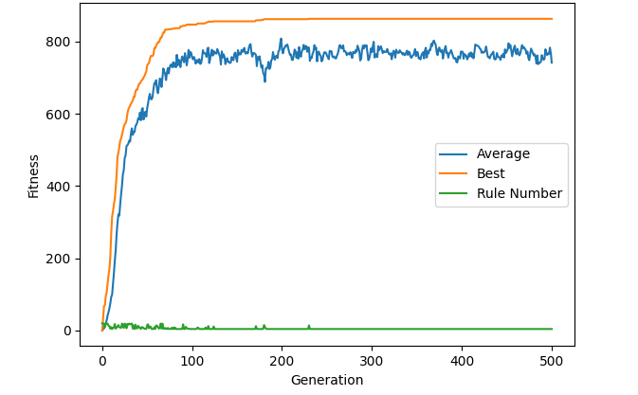

Deciphering the genome

As a final analysis, it is important to investigate the results produced by the algorithm from a manual perspective, in order to see what information about the data sets can be observed. This technique may be required in applications where data mining is used for feature extraction of the data set, which can be later be used to manipulate the data set or the way in which it is collected (citation needed).

In order to examine the readability of the algorithm’s results, the highest performing genome from the nested cross validation technique with genome compression from data set 1 is investigated. This is because it had the highest fitness while retaining a small genome, making the results easier to interpret. Here is the genome outputted from the algorithm:

[0.2569752244532422, 0.7677804675200207, 0, 1, 0, 1, 0, 0.6888602357571432, 0, 0.15995737319298753, 0.26000303037706174, 0.9649481569648961, 0.07749397011045515, 0, 1, 0.44498009030002783, 0.7364319508474593, 0, 1, 0.5200849129225364, 1, 0, 0.25707352320440807, 0, 0.9557817431268466, 0.32577905218928643, 0, 1, 0.15480047310444878, 0.9357823727920461, 0, 1, 0, 0.8869180910372175, 0, 1, 0.004498101765539553, 1, 0.5669909776062353, 0, 0.9356717669425502, 0, 1, 0, 1, 0, 1, 0.03160604062202066, 0.4200950638805167, 0.6591731387680398, 1, 0.6906413877321006]

The values are rounded to 2 decimal places while the classification is rounded to the nearest whole number for easier analysis:

[0.25, 0.76, 0, 1, 0, 1, 0, 0.68, 0, 0.15, 0.26, 0.96, 0,
0, 1, 0.44, 0.73, 0, 1, 0.52, 1, 0, 0.25, 0, 0.95, 0,
0, 1, 0.15, 0.93, 0, 1, 0, 0.88, 0, 1, 0.00, 1, 1,
0, 0.93, 0, 1, 0, 1, 0, 1, 0.031, 0.42, 0.65, 1, 1]

Separated out by pair and then highlighted to reflect the gap size between value pairs….

0.25, 0.76, 0, 1, 0, 1, 0, 0.68, 0, 0.15, 0.26, 0.96, 0
0, 1, 0.44, 0.73, 0, 1, 0.52, 1, 0, 0.25, 0, 0.95, 0
0, 1, 0.15, 0.93, 0, 1, 0, 0.88, 0, 1, 0.00, 1, 1
0, 0.93, 0, 1, 0, 1, 0, 1, 0.031, 0.42, 0.65, 1, 1

From this result, a number of insights can be inferred from the data set. The first of these is that both 5th position pairs for data set 1 were very strict around the value of zero, suggesting that to be classified as 0, the 5 value in the data should be 0 or close to it. Another inference that can be extrapolated is that for both data types, the 3rd value pair is very wide, accepting any value between 0 and 1. This means that the 3rd value in any piece of data is independent of it’s classification, and hence isn’t a relevant metric. Finally, the 6th value pair for the 0 class doesn’t extend to 1, suggesting that the 6th value shouldn’t be higher than 0.96.

This analysis demonstrates that the results obtained from the genetic algorithm can be manually analysed, and suggests that changes to the way in which the data is recorded could be implemented in the future to reduce complexity. For example, it could be argued that the collection of the 3rd value for each data piece is likely unnecessary in data set 1 as it doesn’t play a role in categorising the results.

Conclusions
- Next time it would be worth exploring how different crossover and selection algorithms affected performance. Could then use nested cross validation to decide on the best method for the given problem

References

Appendix

